- Incorrect login information
  - Bad username
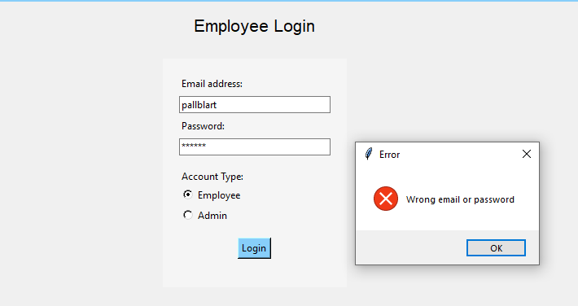
  - Bad password
A notification pops up if either the email or password doesn’t match one in the system
- New employee missing input
  - Missing first name
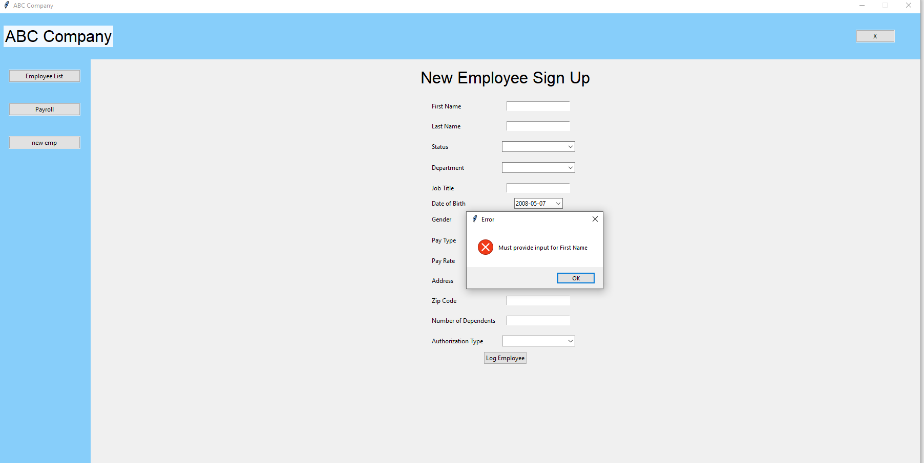
  - Missing last name
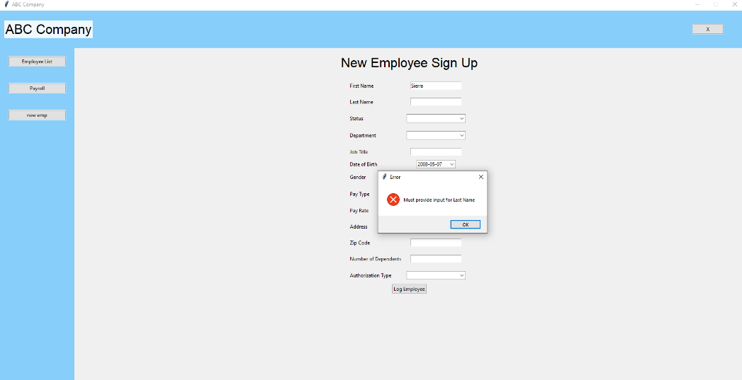
  - Missing status
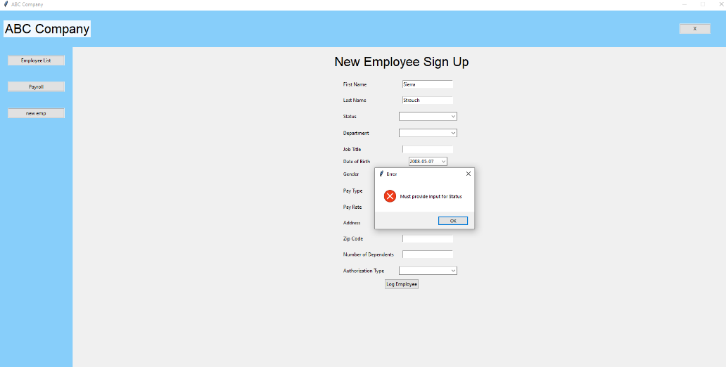
  - Missing department
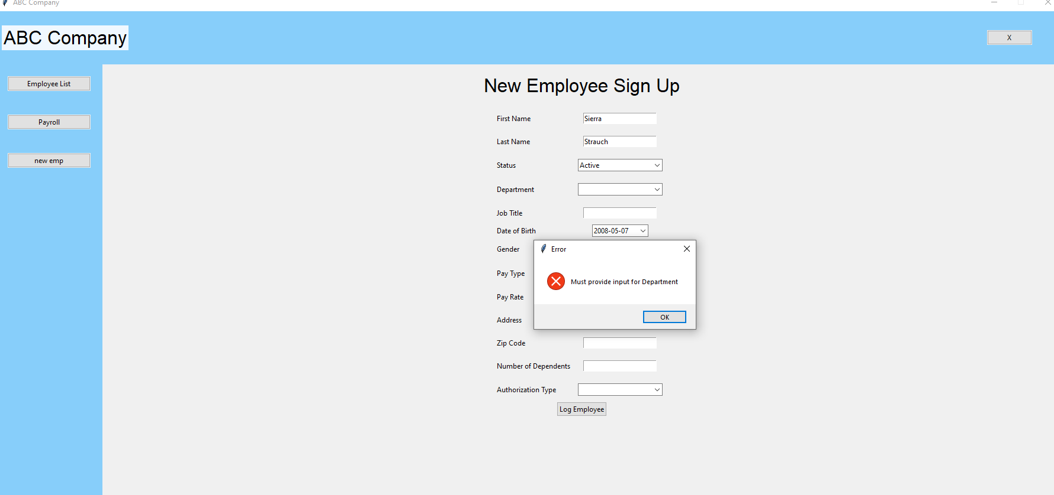
  - Missing title
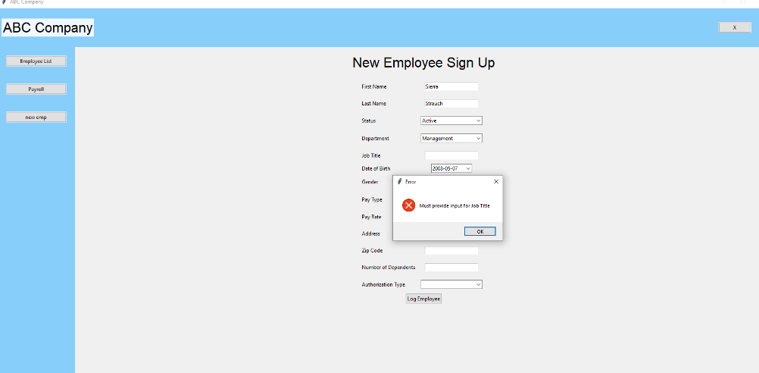
  - Missing birthday
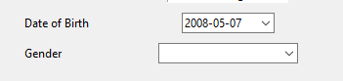
Birthday defaults to the most recent date that someone could be born and be 18 years old. Since it’s required to be 18 to work here.
  - Missing gender
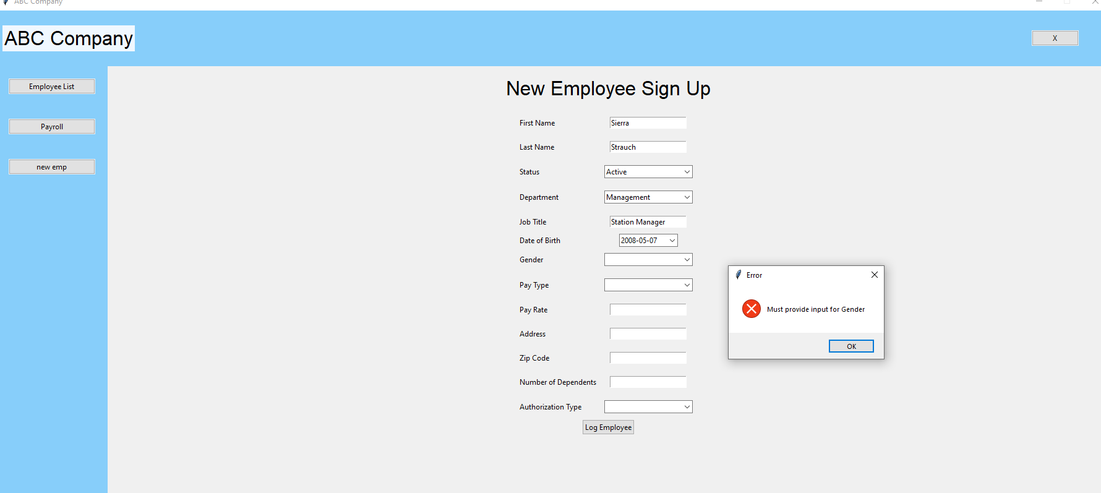
  - Missing pay type
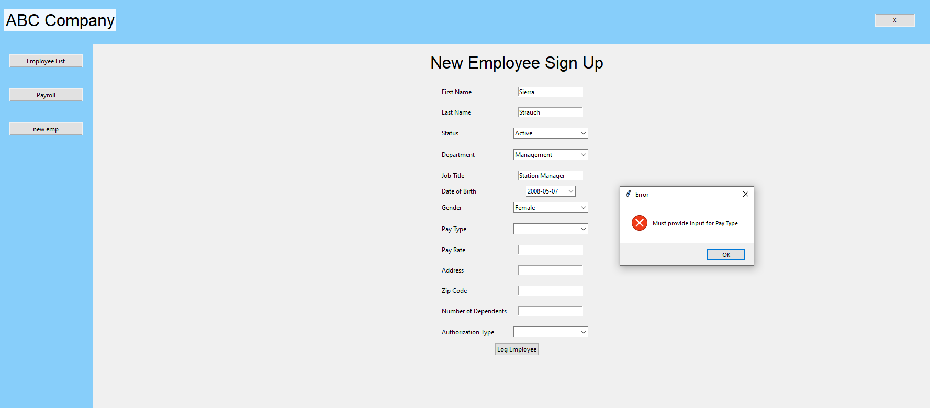
  - Missing pay rate
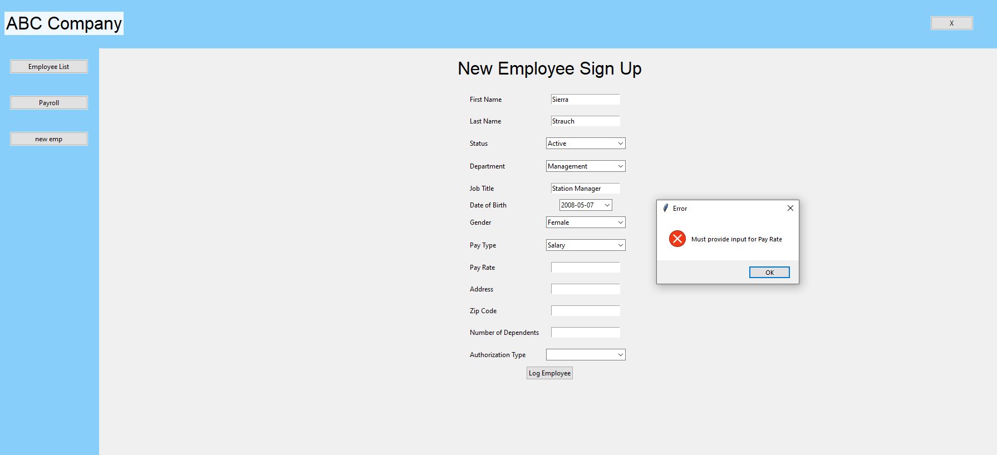
  - Missing address
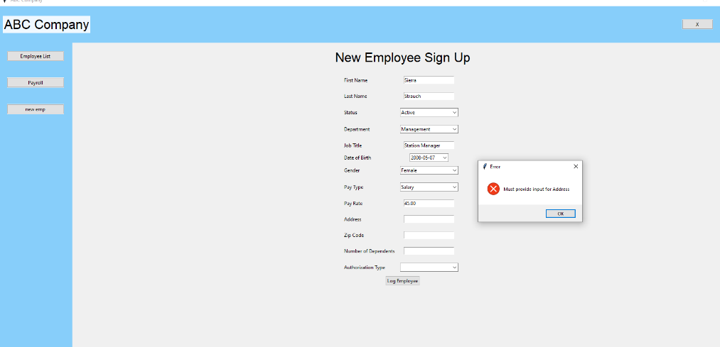
  - Missing zip code
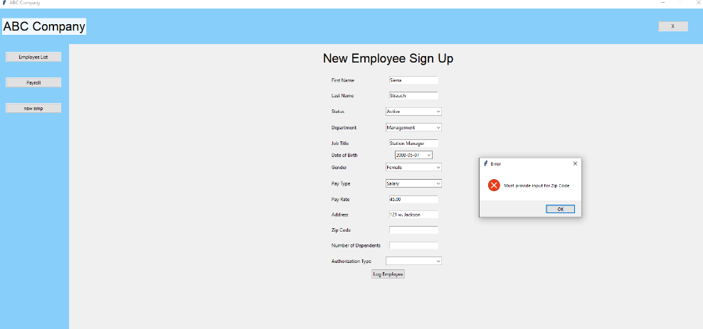
  - Missing dependents
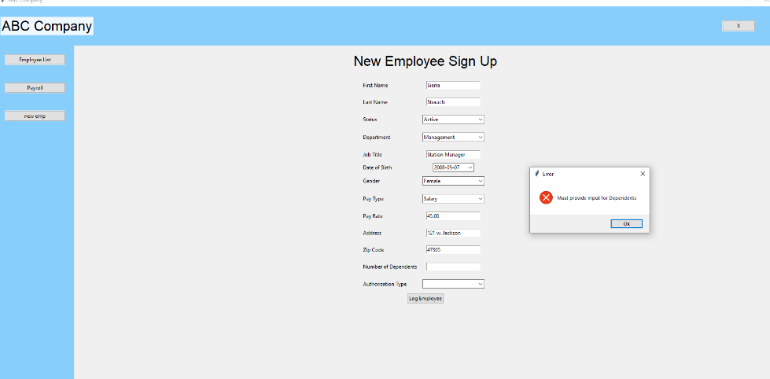
  - Missing admin designation
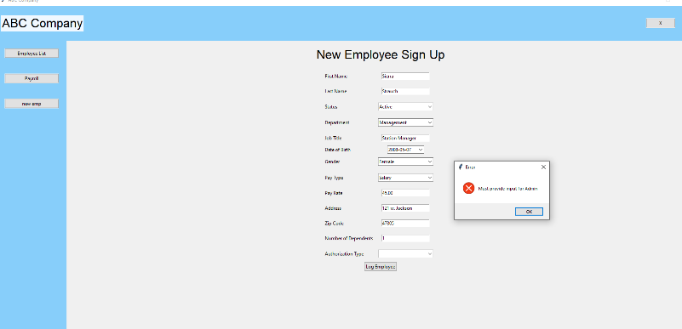
Every field has a custom missing alert if the field is missing. The form can not be submitted if every field is not filled in.
- New Employee bad zip code input
  - Too many numbers
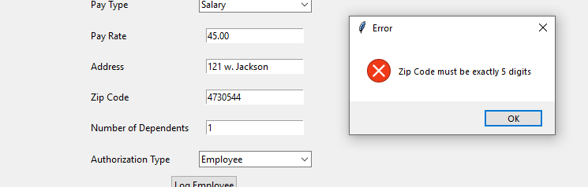
  - Too few numbers
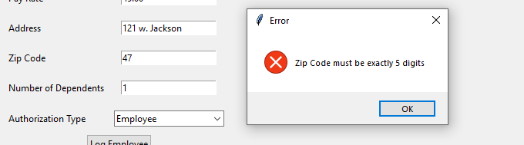
  - Non digit input
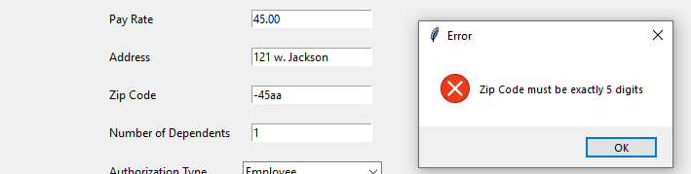
The zip code field has strict controls to make sure only 5 digits can be entered.
- New employee bad dependent input
  - Too many numbers
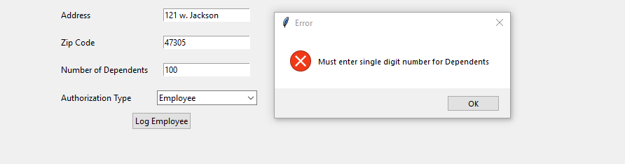
  - Negative number
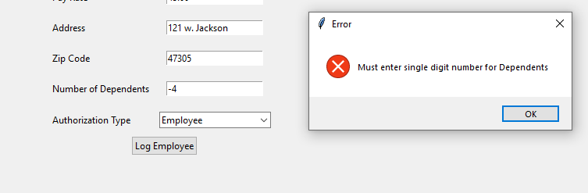
Validation on the dependent number is there to ensure no negative or absurdly high numbers are entered.
- New employee bad pay rate input
  - Not decimal input
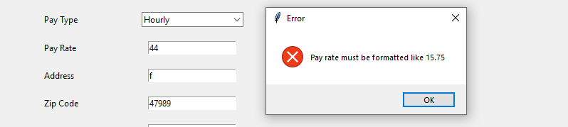
  - Not digit input
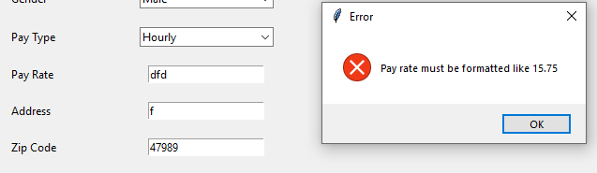
Validation ensures pay rate is a float so that calculations can be certain they are accurate later.
- Pay calculations
  - I need to test if all the pay and deduction calculations are accurate
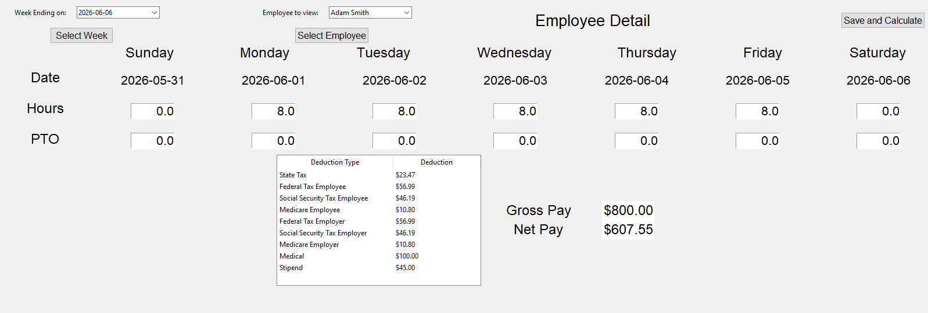
Adam is an hourly worker at a pay rate of 20.00 an hour. He has1 dependent.
  - Gross pay – for 40 hours at 20.00 an hour he should be at 800.00. correct
  - Medical – should be taken before taxes. He has a dependent so it should be 100 dollars. correct
  - Stipend – he has one dependent so he should get 45 dollars. Correct
His new pretax net is 800- 100 + 45 = 745
  - State tax – this is a 3.15% tax so 745 * 0.0315 = 23.47. correct
  - Federal tax employee – 7.65% so 745 * 0.0765= 56.99. correct
  - Federal tax employer – 7.65% so 745 * 0.0765= 56.99. correct
  - social security tax employee – 6.20% so 745 * 0.062 = 46.19, correct
  - social security tax employer – 6.20% so 745 * 0.062 = 46.19, correct
  - medicare employee – 1.45% so 745 * 0.0145 = 10.80. correct
  - medicare employer – 1.45% so 745 * 0.0145 = 10.80. correct
  - Net pay – only subtract the employee portions so 745 –(56.99 + 46.19 + 10.80+23.47) = 745-137.45 = 607.55 which is correct.

